***Week 08 Coding***

***Program 1***

*Coders here is a simple task for you, you have given an array of size N and an integer M.*

*Your task is to calculate the difference between maximum sum and minimum sum of N-M elements of the given array.*

*Constraints:*

*Input:*

*First line contains an integer T denoting the number of testcases.*

*First line of every testcase contains two integer N and M.*

*Next line contains N space separated integers denoting the elements of array*

*Output:*

*For every test case print your answer in new line*

*SAMPLE INPUT*

*51*

*12345*

*SAMPLE OUTPUT*

*4*

*Explanation*

*M is 1 and N is 5 so you have to calculate maximum and minimum sum using (5-1*

*Maximum sum using the 4 elements would be (2+3+4+5=)14.*

*Minimum sum using the 4 elements would be (1+2+3+4=)10.*

*Difference will be 14-10=4.*

*z) 4 elements.*

***Coding***

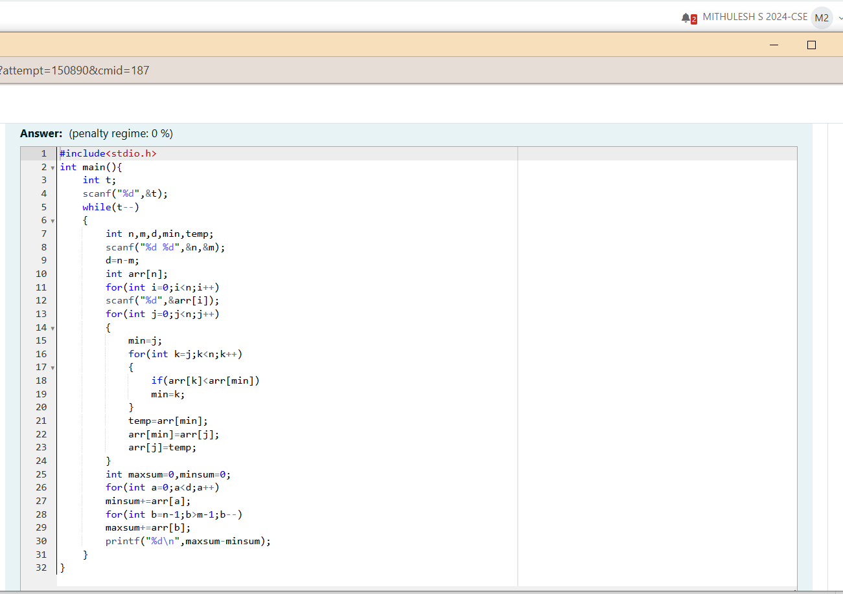

***Output***

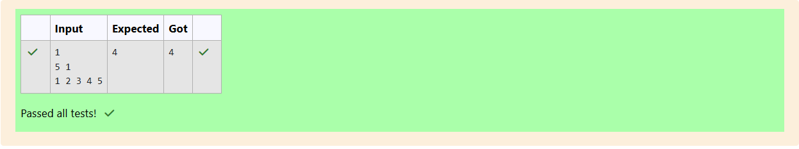

***Program 2***

*A new deadly virus has infected large population of a planet. A brilliant scientist has discovered a new strain of virus which can cure this disease. Vaccine*

*produced from this virus has various strength depending on midichlorians count. A person is cured only if midichlorians count in vaccine batch is more than*

*midichlorians count of person. A doctor receives a new set of report which contains midichlorians count of each infected patient, Practo stores all vaccine*

*doctor has and their midichlorians count. You need to determine if doctor can save all patients with the vaccines he has. The number of vaccines and patients*

*are equal.*

*Input Format*

*First line contains the number of vaccines - N. Second line contains N integers, which are strength of vaccines. Third line contains N integers, which are*

*midichlorians count of patients.*

*Output Format*

*Print a single line containing 'Yes' or 'No'.*

*Input Constraint*

*1 < N < 10*

*Strength of vaccines and midichlorians count of patients fit in integer.*

*SAMPLE INPUT*

*5*

*123 146 454 542 456*

*100 328 248 689 200*

*SAMPLE OUTPUT*

*No*

***Coding***

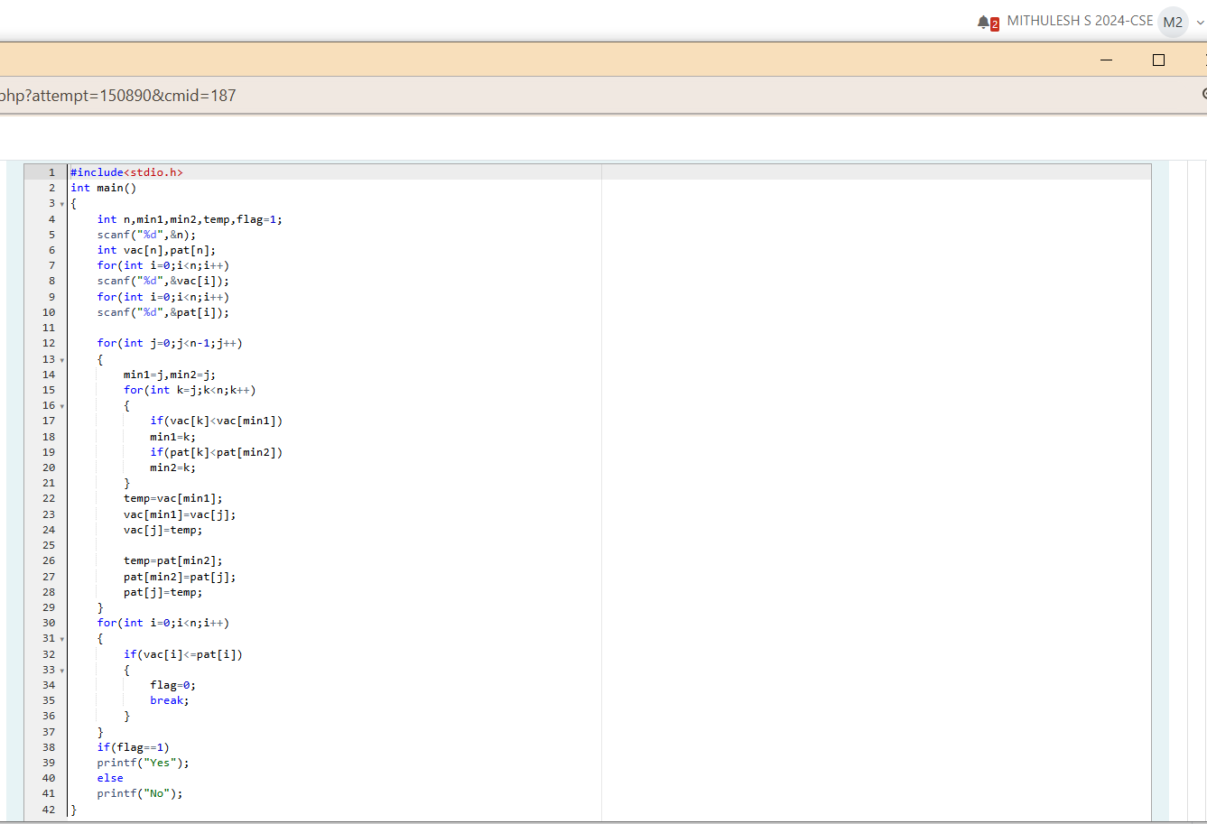

***Output***

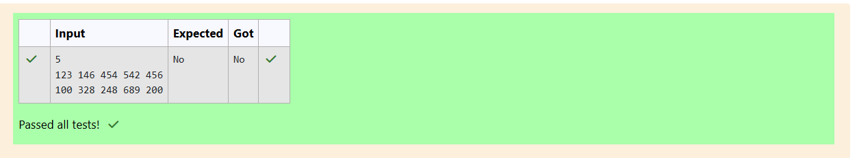

***Program 3***

*You are given an array of n integer numbers al. a-Z.... , an. Calculate the number of pair of indices (i, j) such that 1 i < j n and ai xor aj = O.*

*Input format*

*- First line: n denoting the number of array elements*

*- Second line: n space separated integers ap a2, ... , a*

*Output format*

*Output the required number of pairs.*

*Constraints*

*106*

*109*

*SAMPLE INPUT*

*5*

*13143*

*SAMPLE OUTPUT*

*2*

*Explanation*

*The 2 pair of indices are (1, 3) and (2,5).*

***Coding***

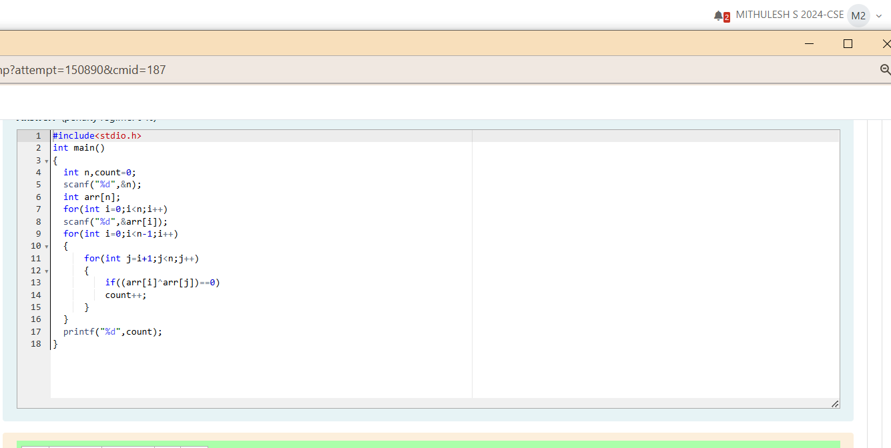

***Output***

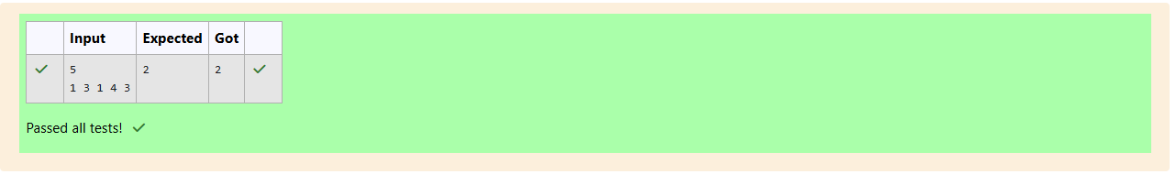

***Program 4***

*You are given an array A of non-negative integers of size m. Your task is to sort the array in non-decreasing order and print out the original indices of the new sorted array.*

*Example:*

*After sorting the new array becomes*

*The required output should be "4 2 0 1 3"*

*INPUT :*

*The first line of input consists of the size of the array*

*The next line consists of the array of size m*

*OUTPUT :*

*Output consists of a single line of integers*

*CONSTRAINTS:*

*NOTE: The indexing of the array starts with O.*

*SAMPLE INPUT*

*5*

*45371*

*SAMPLE OUTPUT*

*42013*

***Coding***

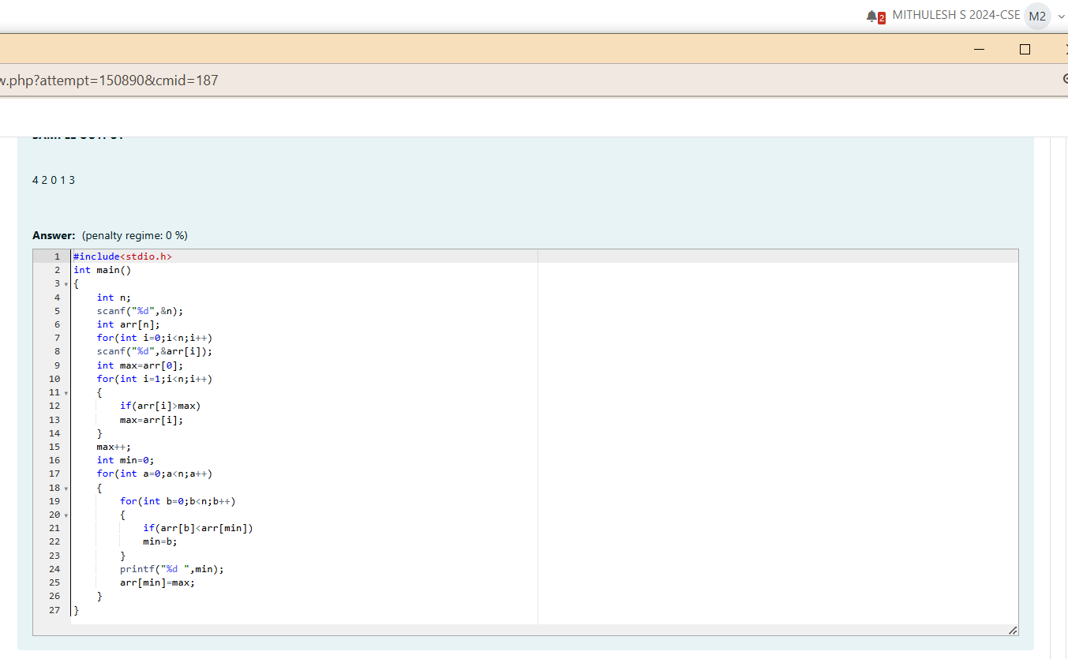

***Output***

